**WRS Evolution**

**Phase One Requirements Elicitation**

Abhilash Ambati

Dylan Meyer

Musa Husseini

Nathan Brown

Tucker Surdock

**Submitted for:**

CPTS 484

Phase 1

9/23/2022

# 

**Revision History** **2**

**1. Introduction** **4**

1.1. Purpose 4

1.2. Scope 4

1.3. Objectives and Success Criteria 5

1.4. Definitions, Acronyms, and Abbreviations 5

1.5. Overview 5

**2. Issues with Preliminary Definition Given** **7**

2.1 Issues with II.1 The Domain, Stakeholders, Functional and Non-Functional Objectives 7

2.2 Issues with II.2 Software System Requirements: Functional Requirements 8

2.3 Issues with II.3 Software System Requirements: Non-Functional Requirements 11

**3. WRS** **15**

**3.1 W** **15**

3.1.1 Problem 15

3.1.2 Goal 15

3.1.3 Improved understanding of II.1 The Domain, Stakeholders, Functional and Non-Functional Objectives` 16

3.1.3.1 Improved Domain 16

3.1.3.2 Stakeholders 16

3.1.3.3 Improved Functional Objectives 16

3.1.3.4 Improved Nonfunctional Objectives 17

3.2 RS 18

3.2.1 Functional RS – Improved understanding of II.2 Software System Requirements: FRs 18

3.2.2 Non-functional RS -Improved understanding of II.2 Software System Requirements: NFRs 20

**4. Preliminary Prototype and User Manual** **22**

4.1.Preliminary Prototype 22

4.2 User Manual 27

4.2.1.Visually Impared Manual 27

4.2.2.Caretaker Manual 28

**5. References** **28**

# 

# **Revision History**

| **Date** | **Version** | **Changes** | **Editor/s** |
| --- | --- | --- | --- |
| 9/23/2022 | 1.0 | Initial Draft | Dylan Meyer  Musa Husseini  Nathan Brown  Abhilash Ambati  Tucker Surdock |
| 9/30/2022 | 1.1 | Layout for section 3.1 | Musa Husseini |
| 10/1/2022 | 1.2 | Updated section 2.1 | Dylan Meyer |
| 10/3/2022 | 1.3 | Introduction and Section 2 being refined and layout changes | Musa Husseini  Dylan Meyer  Nathan Brown |
| 10/4/2022 | 1.4 | Changes to section 3 | Musa Husseini  Dylan Meyer |
| 10/14/2022 | 1.5 | Changes to section 3.2 | Tucker Surdock |
| 10/15/2022 | 1.6 | Changes to Section 4.1 | Musa Husseini |
| 10/16/2022 | 1.7 | Final Edits | Dylan Meyer  Musa Husseini  Nathan Brown  Abhilash Ambati  Tucker Surdock |

# **1. Introduction**

## **1.1. Purpose**

The purpose of this project is to develop a smartphone app that can be used to assist in navigation through indoor spaces. This app will need to be accessible for use by blind people, but should also be configurable by caretakers.

The app would need to map out indoor spaces in order to generate potential routes from the input starting position and the input destination, and correctly select the quickest route available. If possible, map data can be collected through the internet to speed up the route mapping process. The app must generate multiple series of directions in order to navigate from the starting location to an input destination, and using AI select the fastest route available. The directions must be output as audio instructions to walk for a set distance or to turn. Additionally, this app would need to take advantage of multiple sensors on smartphones that would allow for obstacle detection, and if necessary will need the functionality to adjust the course of direction to ensure safe and timely travel.

When beginning this project there are multiple key factors and concerns that need to be noted and worked with. Safety needs to be this application's number one priority. Ensuring the application is able to detect obstacles, collisions, and any other worldly factor that can harm the user needs to be taken into consideration. A second key factor would be the time it takes to reach a destination. Being able to calculate the most efficient and safest path will be crucial in the development and planning. A third key factor that needs to be taken into consideration is the route chosen by the application. It needs to make sure that it is suitable to be used by the user despite traffic, weather, and obstacles. Ensuring those three components are kept in mind when developing will help keep the product in scope. The final factor needed is to ensure the application can communicate with the user orally. If the application cannot vocalize instructions, the user will be in danger and unable to reach their destination.

## **1.2. Scope**

The scope of this project is to provide an application that can be used on different types of devices. Overall, the application will follow the three main key factors mentioned before. Keeping these three factors will keep the project in scope. The main functionalities of the application will be

* Provide a safe route for the user to get to their destination
* Provide a fast and efficient way to reach the destination
* Ensure the route provided accounts for all accessibility needs
* Ensure the application can properly communicate with the user

## **1.3. Objectives and Success Criteria**

The projects objectives and success criteria are that the software must:

* Communicate with the user orally
* Prioritize user safety
* Find the fastest and most efficient route to the destination
* The route is accessible for blind and visually impared
* Each user is able to modify certain preferences (i.e volume, alerts, etc…)
* Fast response time to guide user
* Detect obstacles
* Reroute the user if needed

## **1.4. Definitions, Acronyms, and Abbreviations**

| **Term** | **Definition** |
| --- | --- |
| Accessibility | The quality of being able to be reached or entered |
| NFR | Non-functional Requirements |
| FR | Functional Requirements |
| WRS | World Requirement Specification |
| Agile | A software process model where the project is split into separate portions to be completed. |
| Caretaker | A person responsible for assisting another person |
| Sensors | Devices used to detect surrounding input |

## **1.5. Overview**

This document is split into seven major sections. Section 2 will cover the issues with the preliminary definitions given. Section 2.1 will focus on issues with the domain, stakeholders, function objectives, and nonfunctional objectives. Section 2.2 will focus on issues with the functional requirements, while section 2.3 focuses on issues with the nonfunctional requirements.

Section 3 covers the world requirement specifications. Section 3.1.1 will cover multiple problems and connect them with a likewise goal that can solve it in section 3.1.2. Section 3.1.3 will provide an improved understanding of the domain, stakeholders, function, and nonfunctional objectives. Section 3.2.1 will cover the improved understanding of the functional system requirements while section 3.2.2 will cover the improved understanding of the nonfunctional system.

In Section 4 it will provide a preliminary prototype and user manual to the application. It will provide useful information for the user on how to operate and give a prototype of what the application will look like.

Section 5 covers traceability. It will discuss how traceable the application is between the WRS, FR, and NFR, both forward and backwards.

Section 6 will be references we used to help complete this project.

# **2. Issues with Preliminary Definition Given**

## **2.1 Issues with II.1 The Domain, Stakeholders, Functional and Non-Functional Objectives**

| **Domain Issues ID** | **Description** | |
| --- | --- | --- |
| Domain 1: Ensuring audio instructions from the app are heard by the user. | It isn’t possible to ensure the user is able to hear the instructions in a noisy location. | |
| **Option 1** | Button on app to repeat last instruction |
| **Option 2** | Repeat the instruction after a set period of time. |
| **Choice** | Option 2 |
| **Rationale** | A button on the app would not be ideal since the user likely will not be able to see the button to interact with. |
| **Satisfied By** | Domain 1 | |

| **Domain Issues ID** | **Description** | |
| --- | --- | --- |
| Domain 2: Providing app access to secondary stakeholders | What level of access should be granted to hospital workers or police? | |
| **Option 1** | Special access menu with specific functions for secondary stakeholders |
| **Option 2** | Full access to all functions of the app |
| **Choice** | Option 1 |
| **Rationale** | Full access to the app would give secondary users too many options when they only need to perform specialized tasks. |
| **Satisfied By** | Domain 2 | |

| **Domain Issues ID** | **Description** | |
| --- | --- | --- |
| Domain 3: Ensuring audio instructions from the user are heard by the app. | The noise around the user could be picked up by the app while listening for input | |
| **Option 1** | Auto detect background noise and filter it out |
| **Option 2** | Allow user to Pause input until they noise quiets down |
| **Choice** | Option 1 |
| **Rationale** | It would be difficult for a blind user to go to a quieter space on their own, and it may take a long time for noise to die down in a very busy location. |
| **Satisfied By** | Domain 3 | |

| **Domain Issues ID** | **Description** | |
| --- | --- | --- |
| Domain 4: What languages should be supported | How many languages should be supported by the app? | |
| **Option 1** | Include the most common languages for the app. |
| **Option 2** | Only include English |
| **Choice** | Option 1 |
| **Rationale** | Increased language support is ideal to reach a broader range of users. |
| **Satisfied By** | Domain 4 | |

## **2.2 Issues with II.2 Software System Requirements: Functional Requirements**

| **Domain Issues ID** | **Description** | |
| --- | --- | --- |
| FR 1: Accepting from the user the destination location to go. | Ambiguous. How should the user specify the destination? | |
| **Option 1** | Enter floor and room number. |
| **Option 2** | Require building schematics to specify a scheme (room/floor numbers, names of office owners, names of wings, etc) which can be communicated to the user. |
| **Choice** | Option 2 |
| **Rationale** | Not all buildings will have room numbers and some buildings may have duplicates. Better to take it on a case-by-case basis. |
| **Satisfied By** | FR 1 | |

| **Domain Issues ID** | **Description** | |
| --- | --- | --- |
| FR 2: Figuring out the routes to reach the destination, and informing the user of the options | How to describe multiple routes to user? | |
| **Option 1** | List all turns or corridors of each route. |
| **Option 2** | State length of alternate routes and where they diverge. |
| **Choice** | Option 2 |
| **Rationale** | If the destination is far away, listing all parts of 2 or more possible routes would be tedious. Better to give less information. If the user is familiar with the building, stating whether the paths diverge should be sufficient. Otherwise it likely won’t matter to the user. |
| **Satisfied By** | FR 2 | |

| **Domain Issues ID** | **Description** | |
| --- | --- | --- |
| FR 3: Telling the user to walk a distance | How to determine pace? | |
| **Option 1** | Use the average walking speed of an adult. |
| **Option 2** | Estimate avg speed of users as they use the app. |
| **Choice** | Both |
| **Rationale** | Avg speed of an adult can be used initially, then adjusted to more closely match the user’s own avg speed as they use the app more. |
| **Satisfied By** | FR 3 | |

| **Domain Issues ID** | **Description** | |
| --- | --- | --- |
| FR 4: Telling the user to stop at the right place to turn. | Somewhat poorly worded. Does this really mean, “have the user come to a full stop”? | |
| **Option 1** | Full stop to wait for instructions or check for obstacles or something. |
| **Option 2** | Give next directions shortly before turn and again when turn is necessary. |
| **Choice** | Option 2 |
| **Rationale** | Really no need to come to a full stop at every turn as the user is expected to be inside a building and not needing to stop for traffic. |
| **Satisfied By** | FR 4 | |

| **Domain Issues ID** | **Description** | |
| --- | --- | --- |
| FR 5: Detecting obstacles and telling the user what to do in order to avoid collision. | Being able to protect the user is important. | |
| **Option 1** | Remove requirement entirely. |
| **Option 2** | Include potential for some physical add-on which can scan for obstacles. |
| **Choice** | Option 2 |
| **Rationale** | User safety is of utmost priority. Having sensors and an audible warning can help keep the user safe. |
| **Satisfied By** | FR 5 | |

| **Domain Issues ID** | **Description** | |
| --- | --- | --- |
| FR 6: Placing emergency calls and messages, possibly after detecting a fall or when the system has lost its current  location. | If the user has stopped making progress on the walk, we will want the application to know and take safety measures | |
| **Option 1** | Remove feature entirely |
| **Option 2** | Include emergency call on detecting a fall |
| **Choice** | Option 2 |
| **Rationale** | This feature is important for user safety. If a user is injured the app should have some level of responsibility to alert help if needed. . |
| **Satisfied By** | FR 6 | |

| **Domain Issues ID** | **Description** | |
| --- | --- | --- |
| FR 7: Figuring out what the next action(s) would be, based on the user’s schedule or habit, and  suggesting/accepting the user’s choice. | Potentially out of scope | |
| **Option 1** | AI for guessing likely destinations |
| **Option 2** | Suggest destinations previously entered at similar times |
| **Choice** | Option 2 |
| **Rationale** | Adding a machine learning algorithm to the app for this small feature would be overkill. Better to keep it simple. |
| **Satisfied By** | FR 7 | |

## **2.3 Issues with II.3 Software System Requirements: Non-Functional Requirements**

| **NFR Issues ID** | **Description** | |
| --- | --- | --- |
| NFR1:  The system shall help the user safely navigate indoors. | * Are there safety regulations that are written and meant to be followed? * Just saying safely navigate is ambiguous. | |
| **Option 1** | There are predefined safety rules that the user agrees to follow. |
| **Option 2** | The system has its own safety rules that it abides by. |
| **Choice** | Option 1 |
| **Rationale** | If the system can create predefined meanings of keeping the user safe, it will provide a more defined meaning to protecting the user. |
| **Satisfied By** | NFR1 | |

| **NFR Issues ID** | **Description** | |
| --- | --- | --- |
| NFR2:  The system shall lead the user through the fastest route. | What is considered the fastest route and how will it be calculated? Will this calculation take in account increased times for accessibility. | |
| **Option 1** | Using a third party like google maps to find the fastest path. |
| **Option 2** | Making a route that will ensure obstacles are avoided and times are adjusted to match a blind person's pace. |
| **Choice** | Option 2 |
| **Rationale** | Using google maps would be easier, but it won’t guarantee a fast route each time for a blind person. |
| **Satisfied By** | NFR2 | |

| **NFR Issues ID** | **Description** | |
| --- | --- | --- |
| NFR3:  The system shall lead the user through the route that the user would feel the most comfortable with. | How would the app describe the differences in routes to a blind person? | |
| **Option 1** | There would need to be advanced AI that can describe the path options. |
| **Option 2** | The app can find the differences in the routes and describe the differences. |
| **Choice** | Option 2 |
| **Rationale** | It would be easier on the user to hear the main differences in routes rather than a description of each. |
| **Satisfied By** | NFR3 | |

| **NFR Issues ID** | **Description** | |
| --- | --- | --- |
| NFR4:  The system shall be usable for blind people. | What would be considered unusable? | |
| **Option 1** | The volume is too quiet to be heard. |
| **Option 2** | A lack of description when navigating |
| **Choice** | Option 1 |
| **Rationale** | The volume is something that can be fixed by the user on their device. |
| **Satisfied By** | NFR4 | |

| **NFR Issues ID** | **Description** | |
| --- | --- | --- |
| NFR5:  The system shall be ubiquitous. | What would be considered ubiquitous | |
| **Option 1** | The app is available to all devices. |
| **Option 2** | The app is available across all regions. |
| **Option 3** | The system is advertised and well known. |
| **Choice** | Option 1 |
| **Rationale** | Having the application available on all devices will allow all students with a device to use the system. |
| **Satisfied By** | NFR5 | |

| **NFR Issues ID** | **Description** | |
| --- | --- | --- |
| NFR6:  The system shall be customizable to every user: e.g. volume, the interval of instructions, etc. | How customizable should the application be? | |
| **Option 1** | Each user should have a different user experience and modify the app as they need. |
| **Option 2** | All preferences such as volume, instruments, and routes can be modified to suit each individual . |
| **Choice** | Option 2 |
| **Rationale** | There should be a baseline application that cannot be changed and be standard to all users. However allowing small changes such as volume and tools to be used is something that would be beneficial to the user. |
| **Satisfied By** | NFR6 | |

| **NFR Issues ID** | **Description** | |
| --- | --- | --- |
| NFR7:  The system shall be easily extensible to accommodate the following typical variation: variation in interface, language, definitive needs of the user, new features, new sensors and hardware, etc. | How extensible should the scope of the project be. | |
| **Option 1** | There are hundreds of different accessibility tools that are used by blind people. Ensuring that the system works with all of them is near impossible. Keeping the app extensible to the most popular tools would be beneficial. |
| **Option 2** | Research all devices and tools used by blind people and ensure our application can work across all spectrums. |
| **Choice** | Option 1 |
| **Rationale** | It provides a scope of how to configure the app. It allows the application to know where it is going to be run at all times. |
| **Satisfied By** | NFR7 | |

# **3. WRS**

## **3.1 W**

### **3.1.1 Problem**

| **Problem ID** | **Problem Description** | **Corresponding Goals** |
| --- | --- | --- |
| P1 | How do we ensure users can hear and understand directions? | G1 |
| P2 | How much access should be provided to caretakers? | G2 |
| P3 | How should users specify a destination? | G3 |
| P4 | How should time to destination be estimated and communicated? | G5 |
| P5 | What needs to be done to keep users safe as they navigate? | G6 |
| P6 | How shall the best path be determined? | G4 |
| P7 | How should input (other than destination) be given? | G7 |
| P8 | What settings should be customizable? | G7 |
| P9 | How should the app interact with other tools? | G8 |

### 

Figure 1. Goal: “Give directions to the desired location in a safe, usable, and efficient way. 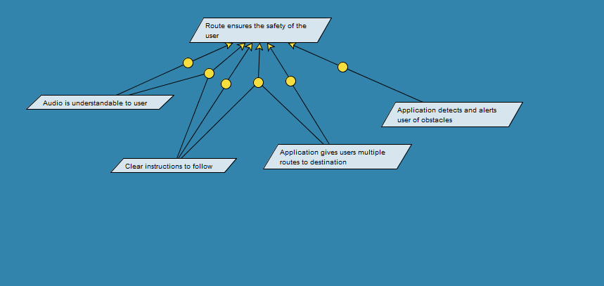

Figure 2. Goal: “Route ensures the safety of the user.”

### 

### **3.1.2 Goal**

| **Goal ID** | **Goal Description** | **Backward Traceability** | **Forward Traceability** |
| --- | --- | --- | --- |
| G1 | Create clear instructions for users to follow. | P1 | D1,FR2,FR3,FR4,NFR3,NFR4, |
| G2 | Allow access by caretakers. | P2 | D2, |
| G3 | Parse user input to choose a destination. | P3 | FR1, |
| G4 | Calculate best path to destination. | P6 | NFR2, |
| G5 | Estimate time to destination. | P4 | FR3,NFR2, |
| G6 | Include safety measures. | P5 | NFR1, |
| G7 | Create voice-navigated menus. | P7. P8 | NFR4,NFR6 |
| G8 | Make tools extensible via API. | P9 | NFR7 |

### **3.1.3 Improved understanding of II.1 The Domain, Stakeholders, Functional and Non-Functional Objectives`**

#### **3.1.3.1 Improved Domain**

| **Improved Domain ID** | **Improved Domain Description** |
| --- | --- |
| ID1 | Ensuring that the user was able to hear the instructions. |
| ID2 | Able to share information with others. |
| IID3 | Ensuring that all instructions are heard by the app. |

#### **3.1.3.2 Stakeholders**

* Sponsors
  + Faculty: Bolong Zeng
* Potential Users of Theia
  + Blind people who need help with reaching a particular location.
  + Partially blind or visually impaired people, who need assistance with navigation
  + Caretakers of blind people who may help them use the app
  + Anyone who needs accessibility when navigating through campus or a building

#### 

#### **3.1.3.3 Improved Functional Objectives**

| **Improved FR Objective ID** | **Objective Description** | **Alleviates Problems** | **Achieves Goals** |
| --- | --- | --- | --- |
| IFRO1 | When accepting the location the user wants to go to, the user will specify the exact details of the location such as room, number, owner, etc.. | P1, P3 | G1, G3 |
| IFRO2 | When figuring out the routes, the system should state the length of alternate routes where they diverge, so it gives the user all the possibilities. | P4, P6 | G4, G5 |
| IFRO3 | When trying to determine the distance a user has to walk, the app will use the average speed of an adult combined with the average speed of the user. | P4 | G5 |
| IFRO4 | When the app needs to tell the user to make a turn in direction, it should give the direction shortly before the turn and when the turn needs to happen. | P1, P5 | G1, G6 |
| IFRO5 | When detecting obstacles, the application will need to determine obstacles in order to keep the user safe | P5 | G6, G8 |
| IFRO6 | If a user seems to have stopped walking or not respond to questions, it should eventually alert medical help. | P5, P8, P9 | G6, G7, G8 |
| IFRO7 | This feature would require advanced AI and take time to build a predictable schedule for the user. | P8, P9 | G8 |

#### **3.1.3.4 Improved Nonfunctional Objectives**

#### 

| **Improved NFR Objective ID** | **Objective Description** | **Alleviates Problems** | **Achieves Goals** |
| --- | --- | --- | --- |
| INFR1 | In order to help the user navigate safely indoors, predefined safety rules will be followed that the user will agree to. | P5 | G6 |
| INFR2 | When considering the fastest route, the route must be chosen such that there are no obstacles in the way. | P6, P5 | G4, G6 |
| INFR3 | To ensure the user is comfortable with the route, the app must describe the differences with the route so that the user can select the one they like. | P6 | G4 |
| INFR4 | To ensure usability, the volume must be loud enough that the user can hear the instructions. | P1 | G1 |
| INFR5 | To ensure the app is ubiquitous, the app must be supported on all mobile devices. | P9 | G8 |
| INFR6 | All preferences such as volume, instruments, and routes must be customizable to suit each individual . | P8 | G8 |
| INFR7 | The app must be easily extensible to accommodate the most popular accessibility tools used by blind people. | P9 | G8 |

## **3.2 RS**

### **3.2.1 Functional RS – Improved understanding of II.2 Software System Requirements: FRs**

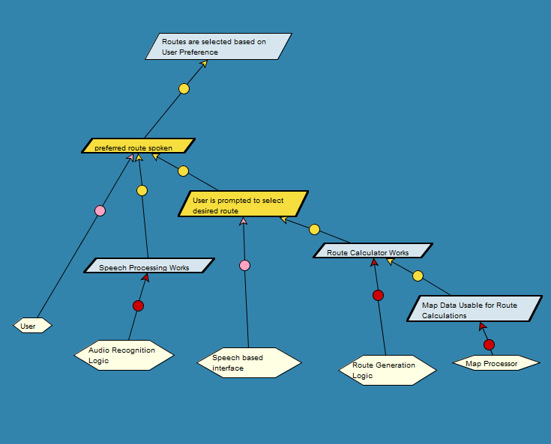

Responsibility 1

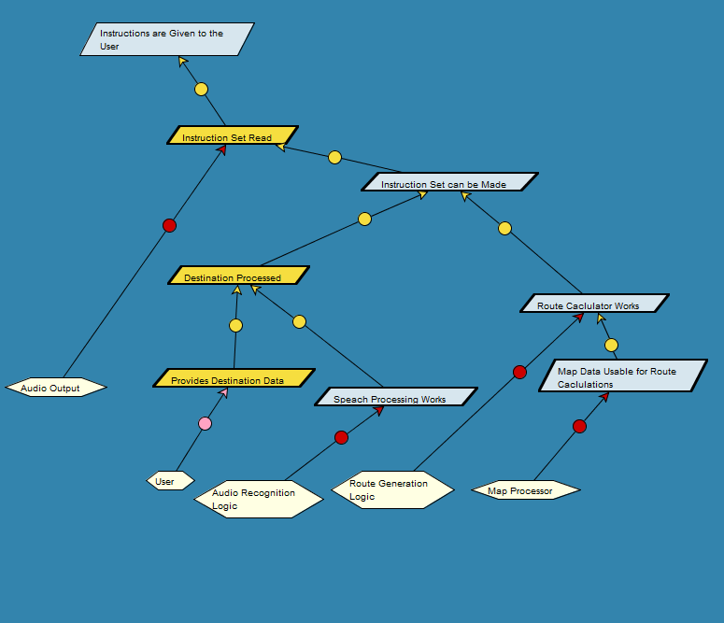

Responsibility 2

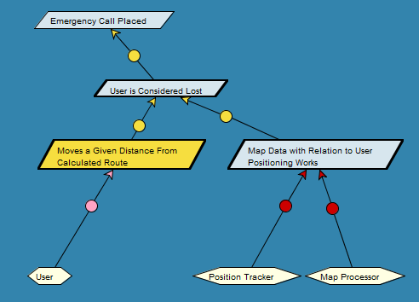

Responsibility 3

| **FR ID** | **Description** |
| --- | --- |
| FR1 | Building schematics will be used to specify room scheme |
| Satisfies Functional Requirement Issue | FR 1 |
| Satisfies Objective | IFRO1, IFRO2 |
| Satisfied by prototype feature | Room Input |

| **FR ID** | **Description** |
| --- | --- |
| FR2 | The length of routes are to be presented to the user so that they can choose the route they like best. |
| Satisfies Functional Requirement Issue | FR2 |
| Satisfies Objective | IFRO2 |
| Satisfied by prototype feature | Route Calculator |

| **FR ID** | **Description** |
| --- | --- |
| FR3 | Average speed of the user is to be tracked over time, starting with a base value. |
| Satisfies Functional Requirement Issue | FR3 |
| Satisfies Objective | IFRO3 |
| Satisfied by prototype feature | Speed tracker |

| **FR ID** | **Description** |
| --- | --- |
| FR4 | Directions will be given shortly before they are to be executed. |
| Satisfies Functional Requirement Issue | FR4 |
| Satisfies Objective | IFRO4 |
| Satisfied by prototype feature | Route Executor |

| **FR ID** | **Description** |
| --- | --- |
| FR5 | Obstacles will not be detected. |
| Satisfies Functional Requirement Issue | FR5 |
| Satisfies Objective | IFRO5 |
| Satisfied by prototype feature | Null |

| **FR ID** | **Description** |
| --- | --- |
| FR6 | Automatic emergency calls will be placed. |
| Satisfies Functional Requirement Issue | FR6 |
| Satisfies Objective | IFRO6 |
| Satisfied by prototype feature | Null |

| **FR ID** | **Description** |
| --- | --- |
| FR7 | Suggestions will be given based on previous activity. |
| Satisfies Functional Requirement Issue | FR7 |
| Satisfies Objective | IFRO7 |
| Satisfied by prototype feature | Activity monitor |

### 

### **3.2.2 Non-functional RS -Improved understanding of II.2 Software System Requirements: NFRs**

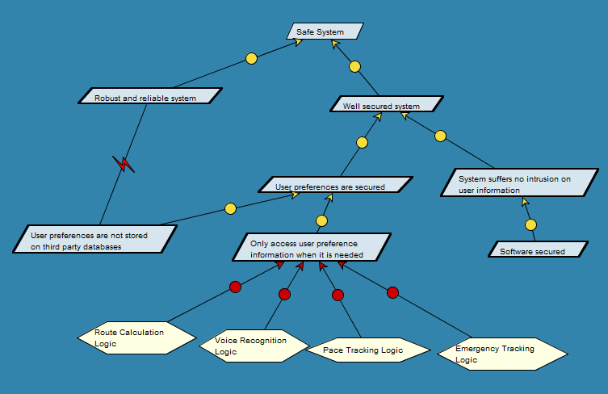

Figure #: Safe System model

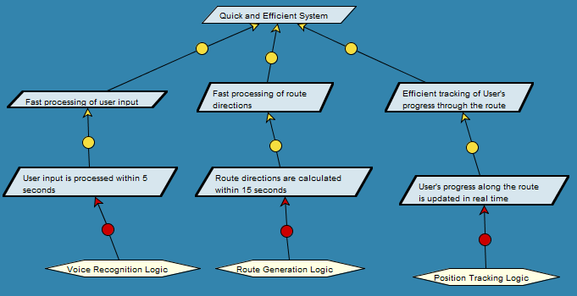

Figure #: Quick and Efficient System model

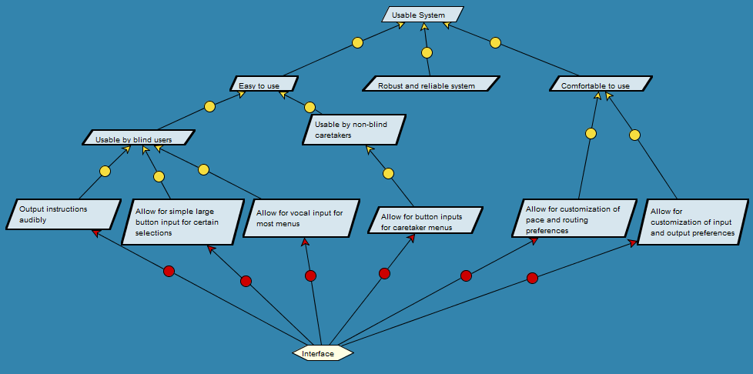

Figure #: Usable System model

| **NFR ID** | **Description** |
| --- | --- |
| NFR1 | The system shall help the user safely navigate indoors. |
| Operationalized Functional Requirements | FR1 |
| Satisfies Nonfunctional Requirement Issue | NFR1 |
| Satisfies Non-functional Objective | INFR1 |
| Constraints | P5 |
| Satisfied by prototype feature | Predefined rules user agrees to. |

| **NFR ID** | **Description** |
| --- | --- |
| NFR2 | The system shall lead the user through the fastest route |
| Operationalized Functional Requirements | FR2 |
| Satisfies Nonfunctional Requirement Issue | NFR2 |
| Satisfies Non-functional Objective | INFR2 |
| Constraints | P4, P6 |
| Satisfied by prototype feature | Route Calculator |

| **NFR ID** | **Description** |
| --- | --- |
| NFR3 | The system shall lead the user through the route that the user would feel the most comfortable with. |
| Operationalized Functional Requirements | FR3 |
| Satisfies Nonfunctional Requirement Issue | NFR3 |
| Satisfies Non-functional Objective | INFR3 |
| Constraints | P6 |
| Satisfied by prototype feature | Route Calculator, Preference Selector |

| **NFR ID** | **Description** |
| --- | --- |
| NFR4 | The system shall be usable for blind people. |
| Operationalized Functional Requirements | FR4 |
| Satisfies Nonfunctional Requirement Issue | NFR4 |
| Satisfies Non-functional Objective | INFR4 |
| Constraints | P1, P3 |
| Satisfied by prototype feature | Audio Instruction Interface |

| **NFR ID** | **Description** |
| --- | --- |
| NFR5 | The system shall be ubiquitous. |
| Operationalized Functional Requirements | FR5 |
| Satisfies Nonfunctional Requirement Issue | NFR5 |
| Satisfies Non-functional Objective | INFR5 |
| Constraints | The app is available to all devices. |
| Satisfied by prototype feature | null |

| **NFR ID** | **Description** |
| --- | --- |
| NFR6 | The system shall be customizable to every user: e.g. volume, the interval of instructions, etc. |
| Operationalized Functional Requirements | FR6 |
| Satisfies Nonfunctional Requirement Issue | NFR6 |
| Satisfies Non-functional Objective | NFR6 |
| Constraints | P8 |
| Satisfied by prototype feature | Caretaker Configuration |

| **NFR ID** | **Description** |
| --- | --- |
| NFR7 | The system shall be easily extensible to accommodate the following typical variation: variation in interface, language, definitive needs of the user, new features, new sensors and hardware, etc. . |
| Operationalized Functional Requirements | FR7 |
| Satisfies Nonfunctional Requirement Issue | NFR7 |
| Satisfies Non-functional Objective | INFR7 |
| Constraints | P9 |
| Satisfied by prototype feature | null |

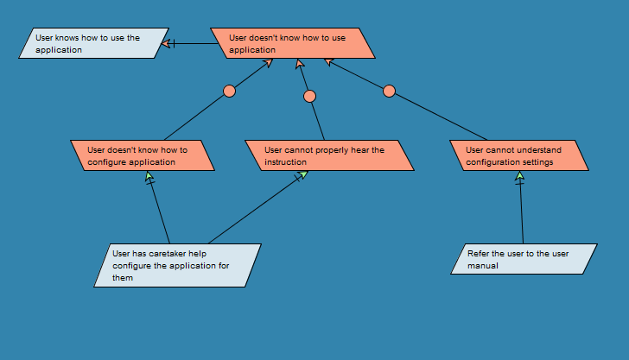

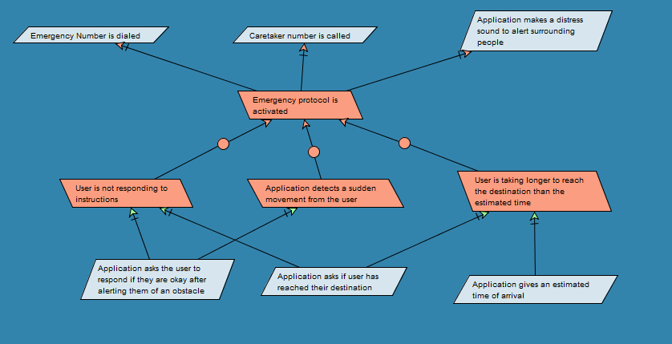

# 

# 

# **4. Preliminary Prototype and User Manual**

## **4.1.Preliminary Prototype**

Scenario 1: Visually Impared User Experience

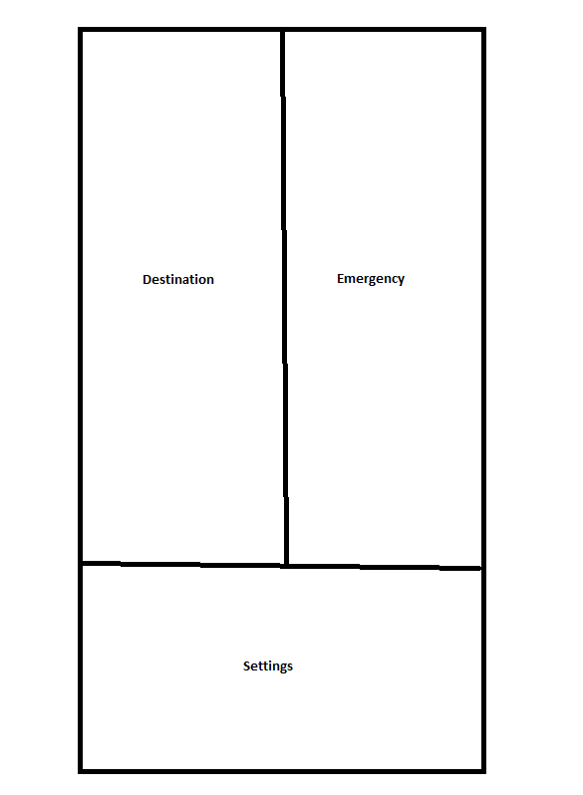

This will be the first screen any user will see. Everything will automatically be voice guided and upon first interaction it will tell the user the location of the three buttons. This is following a simple 3 button layout so a visually impaired user can click on a corner of the screen to get their desired use of the app.

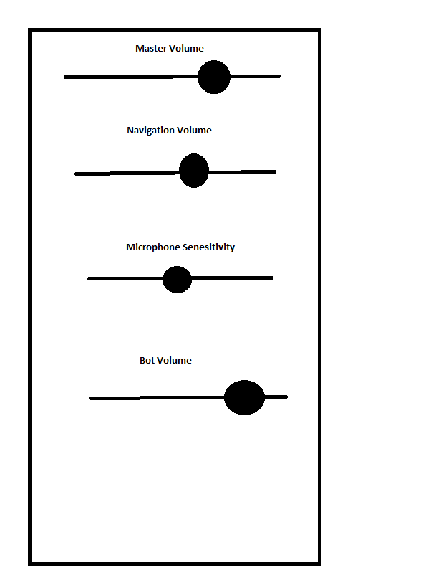

This is not an exhaustive list of all calibration questions. It is showing what it would look like for the current user and what some of the questions would look like. Again all the questions will be asked vocally and the user can say which setting they want and say a number between 0-100 on the volume of each setting.

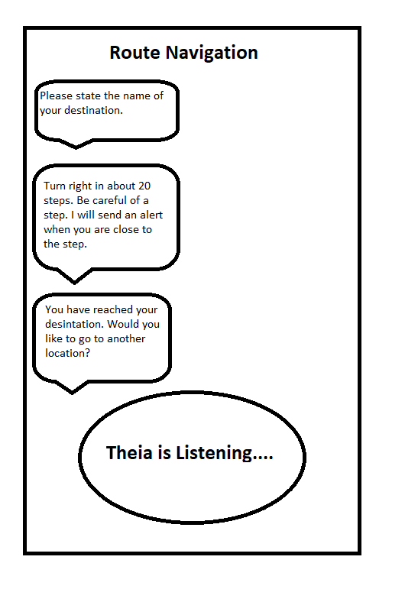

This is a simple example of how a user would get to their destination. When the user selects the destination button it will begin asking questions.Theia would ask for the destination, then give instructions on how to get there. It will give warnings when close to an obstacle and will signal when to turn. It will also ask after they have reached their destination if they want to go elsewhere. The interface will remain on the same original page, but this is an example of how the app will interact with the user.

Scenario 2: Caretaker User Experience

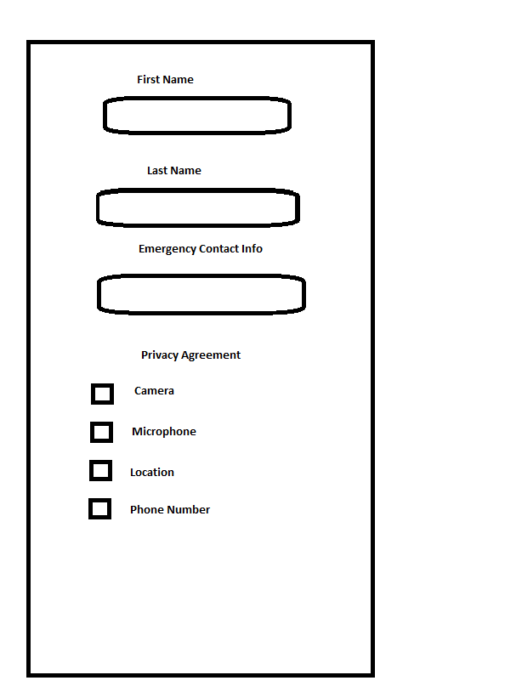

The caretaker will see the same original screen as any other user. Instead they will be able to use the buttons and use the application with their hands rather than just vocally. This screen may also be edited vocally if a visually impaired user wants to use it.

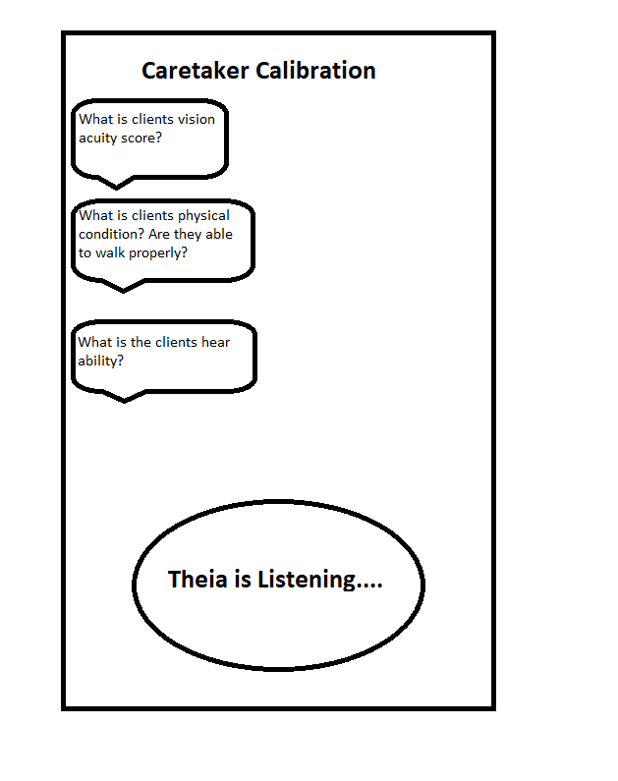

This calibration screen will be a bit different from the visually impared one. It will ask similar questions, but also keep in mind this is not the main user and someone answering on their behalf.

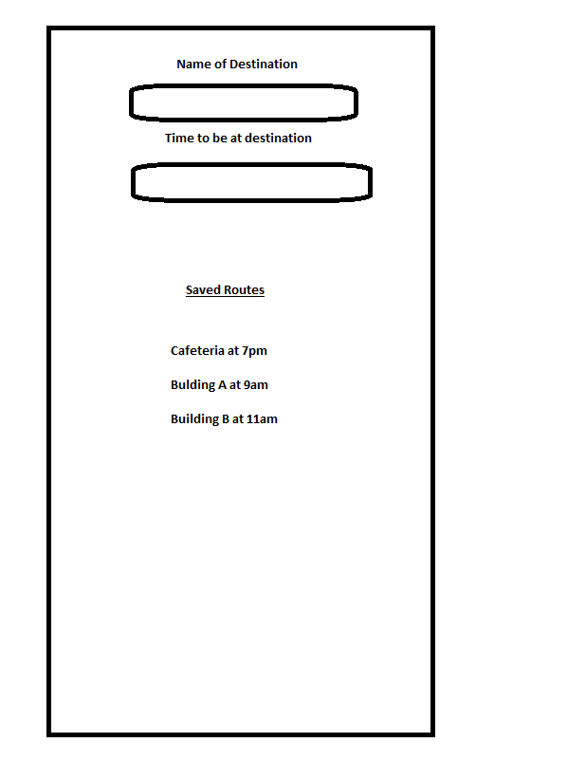

This screen is where a caretaker can enter specific routes to ensure the user gets to the right destination at the right time. They can create a schedule for the user and Theia will begin navigation to get them at the right place at the right time.

## **4.2 User Manual**

### **4.2.1.Visually Impared Manual**

1. Upon installing the application, it will ask if you are a caretaker or a visually impared user. Make sure to respond with “visually impared”.
2. The application will go through a series of tests to determine sound settings to ensure the user can hear properly.
3. The application will then ask the user to enable location settings so it knows where the user is.
4. Upon having the user location, it will ask for the user's destination. The user shall speak to the device and name the location of where they want to go.
5. The app will determine different routes and describe each route to the user, particularly explaining any possible obstacles or safety concerns.
6. The user will answer with the option of route they want to use.
7. Once the route begins, the user must carefully listen to the applications directions and heed any warnings it may give.
8. Once the user has reached the desired location, the application will ask if the user wants to go to another destination, and if not it will end the task.

### **4.2.2.Caretaker Manual**

1. Upon installing the application, it will ask if you are a caretaker or a visually impared user. Make sure to respond with “caretaker”.
2. The application will ask questions about the person the caretaker is responsible for. Questions such as vision, hearing, and physical ability to walk will be asked to determine what type of help the potential user might need.
3. Once the setup is done, the caretaker can allow the person of need to use the application to its full ability. Please refer to section 4.2.1 for a detailed description of how to use the application.

# 

# 

# **5. References**

*(WAI), W. C. W. A. I. (n.d.). Mobile accessibility at W3C. Web Accessibility Initiative (WAI). Retrieved September 14, 2022, from*[*https://www.w3.org/WAI/standards-guidelines/mobile/*](https://www.w3.org/WAI/standards-guidelines/mobile/)

*Peter Loshin, Jessica Sirkin, Structured Query Language, TechTarget.   
Retrieved September 17, 2022 from* [*https://www.techtarget.com/searchdatamanagement/definition/SQL#:~:text=Structured%20Query%20Language%20(SQL)%20is,on%20the%20data%20in%20them*](https://www.techtarget.com/searchdatamanagement/definition/SQL#:~:text=Structured%20Query%20Language%20(SQL)%20is,on%20the%20data%20in%20them)*.*

*OMG. “Unified Modeling Language.” 2017,  
Retrieved September 18, 2022 from*[*https://www.omg.org/spec/UML/2.5.1/PDF*](https://www.omg.org/spec/UML/2.5.1/PDF)*.*

*W3C. “Mobile Accessibility: Hw WCAG 2.0 and Other W3C/WAI Guidelines Apply to Mobile”, February 2015, Retrieved September 18, 2022 from* [*https://www.w3.org/TR/mobile-accessibility-mapping/*](https://www.w3.org/TR/mobile-accessibility-mapping/)

# 